**BOOKING DEALER:**

* It is used to search doctors which are registered with 32Watts on our website(www.32watts.com). User can search doctors by name, clinic name, city and pin.

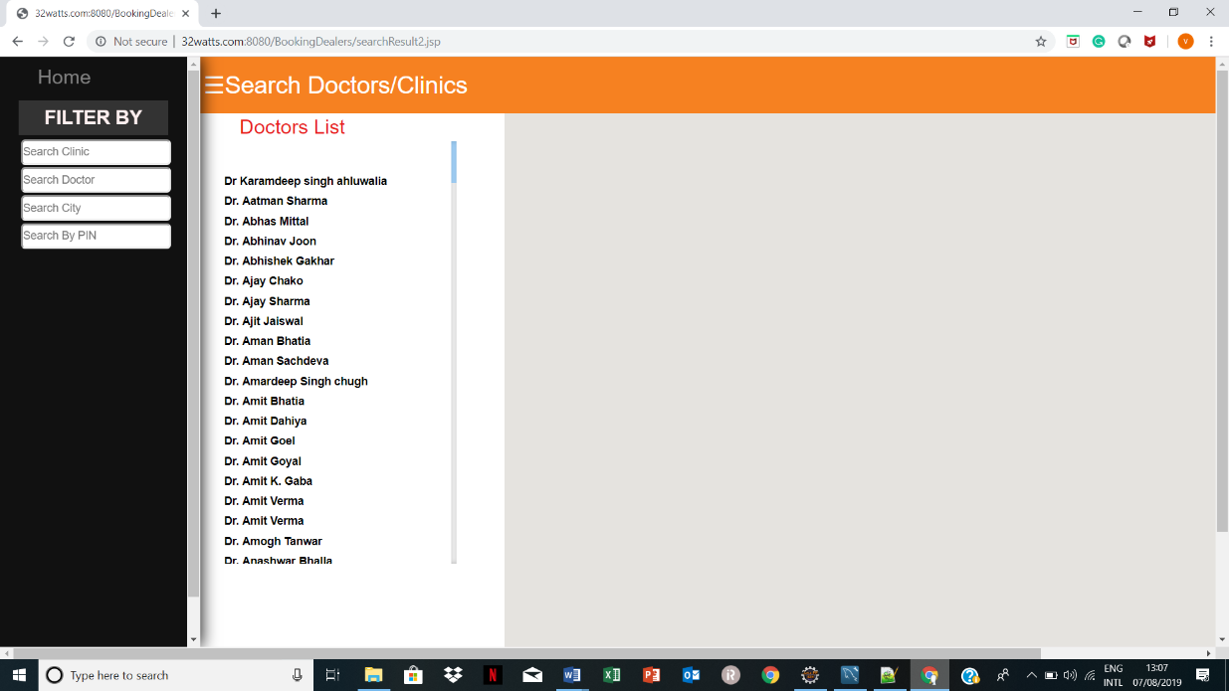

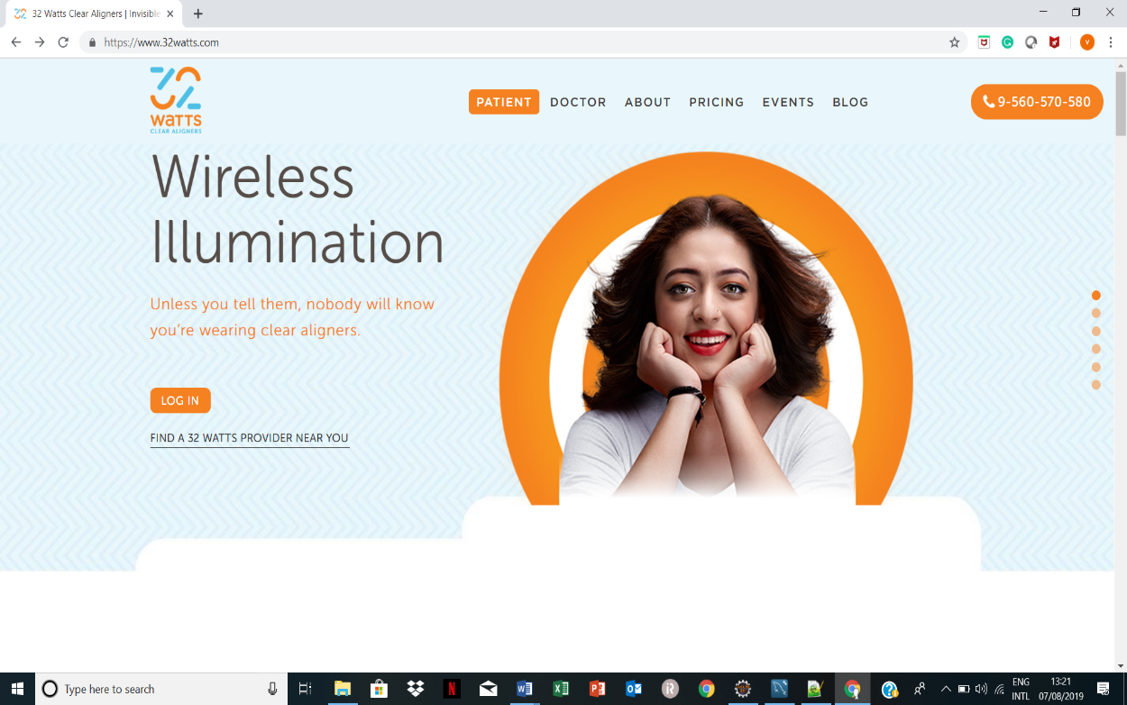

|  |  |  |
| --- | --- | --- |
| File name | Feature | What’s Inside |
| Main.jsp | Requires login id and password | Currently no checks are present.  Anyone can login by simply clicking on it. |
| Login.jsp | Screen which allows to add doctor and search them | User can add orthodontist, add clinic and search for particular doctor |
| addOrthodontist.jsp | Interface to add orthodontist details. | Orthodontist name, clinic name, address, email, state pin all must be filled to add orthodontist. |
| AddClinics.jsp | Interface to add clinic details. | Clinic name, clinic name, address, email, state pin all must be filled to register clinic with us. |
| SearchResult2.jsp | User can search a particular doctor. | User can search doctor by clinic name, city, pin, doctor’s name. |

The database of booking dealer is linked with database of digiplan. The name of database is render_digiplan. Person can access database from cpanel with valid credentials. If person want to deploy war file or want to deploy class file in which user has made changes, then refer to deploy project video manual.

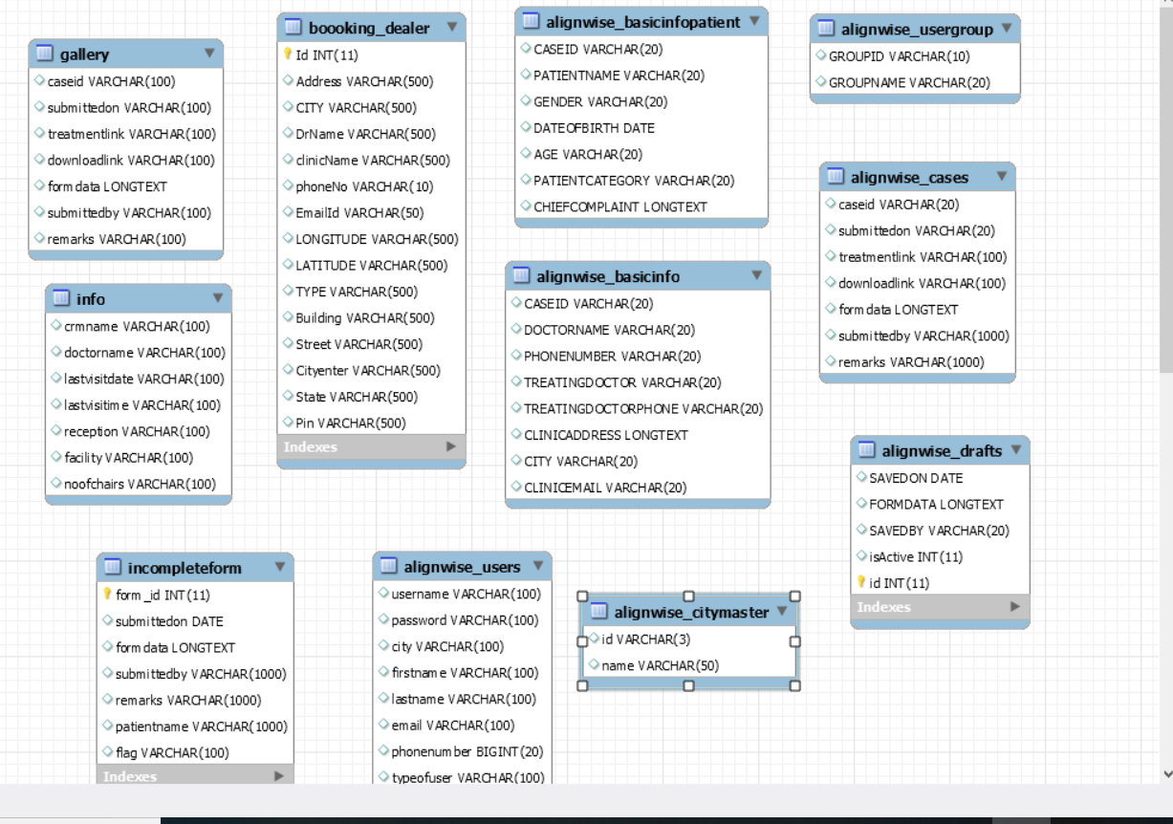

* 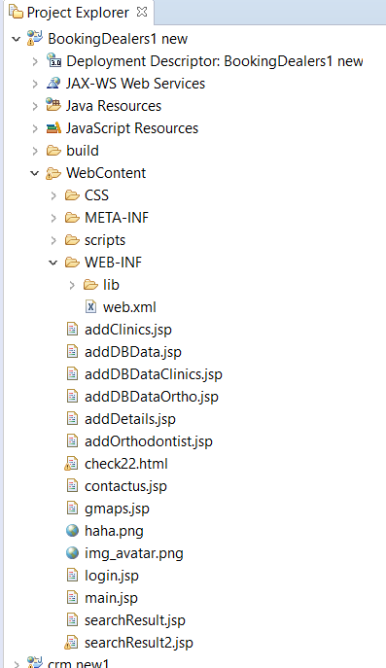This is preview of booking dealer project in eclipse. All these files must be present for proper functioning of project